Luke de Laeter

International Meeting of Young Beekeepers Australian Team Slovenia July 2020

Laetsr

# 123 456 78 90

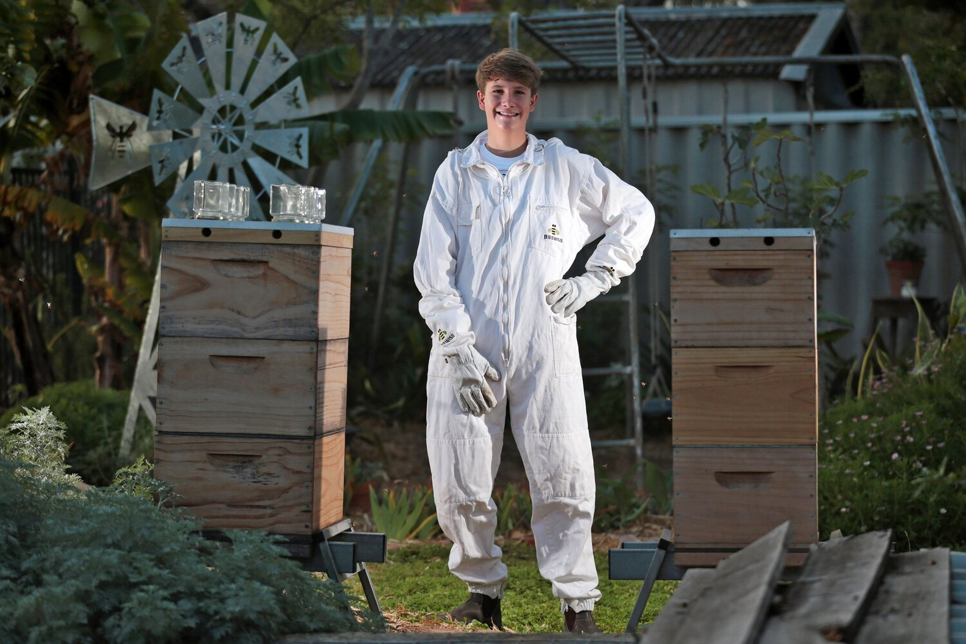

**The Competition, being;**

**The 11th International Meeting of Young Beekeepers (IMYB).**

**When: 6th - 10th July 2020**

**Where: Slovenia, Europe**

* **Australian team to join 40 other countries at IMYB**
* **Learning from other international competitors covering;**
  + **Workshops**
  + **Issues affecting bees intonationally, including**
    - **Food security,**
    - **CCD,**
    - **Spread of diseases; and**
    - **Pests.**

**Luke’s Additional Beekeeping Experiences in Europe,**

* **Visit LYSON location in Poland, including**
  + **Manufacturing division**
  + **Educational center**
  + **Entire range of equipment**
* **Beekeeping work experience with a commercial apiary in Poland for XX weeks**

**FUNDRAISING / DONATIONS/ SPONSORSHIPS**

**This is a once in a lifetime opportunity for Luke, as WAAS member, to be involved with the IMYB.**

**The next step is getting Luke to Slovenia and Poland.**

**THE PLAN**

* **WAAS financial support (Committee approval required)**
* **Industry support (some suppliers already onboard),**
* **Generous personal contributions from WAAS members; and**
* **Luke’s personal financial commitment.**

**If you can donate, WAAS is currently accruing funds on behalf of Luke from donations via our bank account. The details are;**

**Western Australia Apiarists Society**

**BSB 086-288**

**ACCOUNT 16072-8324**

Notation: **Luke Challenge**

(Please put this on the EFT or the Treasure will go nuts!)

**We all look forward to Luke’s presentation upon his return.**

**THE FUTURE OF BEEKEEPING IS IN THE HANDS OF THE YOUNG GENERATION**